CROSBY & district U3A
  - MAY 2026 NEWSLETTER
WE meet on 2nd Monday of the month – Excl. August  st. helen’s church hall, alexandra road, crosby l23 7tq  (Opposite Nat-West Bank and near various bus-stops.)  DOORS open at 1:45 pm.  MEETING starts at 2:00 pm.  TEA & BISCUITS to follow  www.crosby.u3asite.uk  e: crosbyu3a@gmail.com  Facebook Group: Crosby u3a  PRESIDENT: David Atherton  YOUR 2025/26 COMMITTEE  Anne Handley: CHAIR, Web-site Manager; Programme Secretary  Richard Hackford: Vice-Chair; Newsletter Designer  June Chetter: Secretary  Carole Firth: Treasurer  Irene Pepp: Newsletter Editor  Maggie Goodrum: Groups  Co-ordinator  Lesley Iwanejko: Membership Secretary  COMMUNITY NEWS  THE PLAZA CINEMA….  FLICKS AND FRIENDS:  Monthly FREE film strictly for over 60’s provided by “Re-engage”.  Doors: 12:15 pm – FILM: 1:00 pm  Tea and biscuits are served.  FREE - but Donations Welcome  Tues. 12 May: “The Sheep Detectives” – Hugh Jackman and Emma Thompson star in this film which blends a ‘who-dunnit’ comedy with deeper themes.  BOOKING ADVISED: 0151 474 4076  +++++++++++++++++++++++++++++  MESSAGE FROM ‘FLICKS AND FRIENDS’: You may have received a lanyard and QR card on your last visit. Please keep this with you and bring it along each visit. In due course, we will be scanning the cards so we know how successful Flicks and Friends Crosby really is!  If you didn't receive a card please email me* and I'll arrange one to be sent out to you.  Many thanks and enjoy the films.  Helen Shortall.”  *Helen.Shortall@reengage.org.uk  PLAZA CINEMA COMMUNITY SHOP  89 St John's Rd, Waterloo L22 9QD  Phone: 0151 286 0853  This Shop raises funds to support Waterloo’s only remaining Cinema.  They currently need: Bric-a-brac, Ornaments, Clothes, Electrical Goods, Records/CDs/Tapes, Old Bedding, Curtains, Furniture.  Please deliver your donations to the shop, or telephone for collection.  Open: Open every Monday to Saturday daytime.  COMMUNITY NEWS Contd.  FREE LOCAL HISTORY TALKS  Sefton’s Information Service Unit provides FREE monthly talks on a wide variety of topics at Crosby Library. (These are held upstairs – lift available.)  Wed. 6th May at 2:00 pm.  David Hearn: “The First Mersey Road Tunnel” – hailed as the 8th Wonder of the World in the 1930’s, the Queensway Tunnel was a masterpiece in civil engineering.  N.B. Please reserve your free seat by contacting Crosby Library  information.services@sefton.gov.uk  Tel: 0151 257 6401  CROSBY & DISTRICT HISTORY Soc.  Moor Lane Methodist Church Hall, Crosby L23 2UH – (Opposite the old Windmill.) Meets: 7:30 pm.  (Bus stop outside and free on-site parking.)  N.B. THE NEXT TWO TALKS HAVE A SPECIAL FOCUS ON CROSBY.  May 11th – Spencer Leigh - “Merseybeat Memories: a childhood in Crosby”  June 8th – Janet Hardman:  “Alexandra and Coronation Parks in Crosby”  Non-members: £2 per Meeting  For more information contact Bernard Nevin – 07534 685 774  “Genius is one per cent inspiration and ninety-nine per cent perspiration.”  Thomas Alva Edison 1791 - 1867  (from a Newspaper Interview)  CROSBY U3A NEWS EXTRA!  MEMORIES OF CROSBY U3A  In our 30th Anniversary year, it’s good to look back on our time here.  What are the moments that stand out in your memory? Perhaps there was a particularly fun outing, or maybe you made new friends by joining one of the groups that shared your passion for books, art or gardening?  Another person shares their memories here:  “Soon after I joined Crosby u3a, we went on a day trip to Llandudno. It was a beautiful day and we decided to take in the view from the Great Orme. Nearly all of us took the tram, as we couldn’t cope with walking up the steep path in the warm sunshine. But, ONE person chose to walk to the top and, as we stepped off the tram, we realised he’d nearly beaten us! Who was this sturdy walker?  None other than our President, David Atherton!”  Richard  Please send YOUR memories to crosbyu3a@gmail.com or tell them to a committee member at a meeting and we will print some of them in subsquent newsletters.  PLEASE NOTE: Any Articles, News Items or Photos for the JUNE issue to be submitted to the Editor (crosbyu3a@gmail.com)  by Friday 22nd MAY.  _____________________________  Printed by: Copyspot, 44 Crosby Rd. Nth, Liverpool L22 4QQ  0151 920 9998  email: kie@thecopyspot.co.uk |  |  | guest editorial – our SECRETARY…  CROSBY U3A SAVED MY LIFE  Gosh! That’s a bit dramatic I hear you say but it is TRUE!  I joined the Craft Group in 2024, to learn a new skill – “Stumpwork” - a form of 3D embroidery. Last summer I was at that group when I became ill – I couldn’t speak (unusual for me). Unbeknown to me, but not my fellow crafters (Win and Audrey), I was having a stroke. Win kept an eye on me while Audrey called the ambulance. I was taken to the Stroke Unit at Aintree and within two hours of my initial symptoms I was being treated. When I saw the Stroke Consultant later, he told me had I not been treated at the time I could have had a major stroke! I owe my life to my fellow ‘crafties’. They took control, and also notified my family - something for which I shall be forever grateful. They knew my ICE (In Case of Emergency) details and were able to give these to the paramedics.  This is the little box I was working on, in the group at the time, and it will always be very special to me.  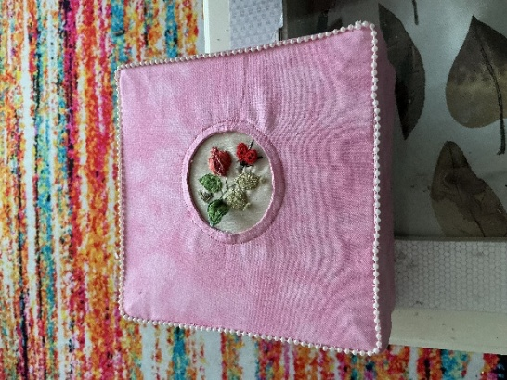  Contd. On Page 2  CROSBY U3A SAVED MY LIFE Contd……  It is so important that your group leaders know where to find your ICE details. They don’t have to see them, just know where they are. They can be in your phone or on a bit of paper in your purse or wallet.  This applies to whether your group meets inside or whether you are out on a trip. We should all look out for each other.  Talking of looking out for each other, we are looking for a new Secretary from September. My 3 years are up. It has flown by and I have enjoyed every minute. I have been part of the team and supported by my fellow committee members and the previous secretary. Being secretary is enjoyable, fun even. It is not an onerous task and you don’t need shorthand skills; I don’t have any of those. You will have help and support all along the way. You get to see the workings of YOUR local u3a and have input. If you think it is something you would like to do please let us know. If you would like to chat with me please see me at the May meeting or email me at crosbyu3a@gmail.com and I will be in touch.  I’m off to pastures new -Yorkshire - in July. I wish Crosby u3a a long, happy and fun-filled future.  June  THIS MONTH’S SPEAKER….  MAY 11th - GILL RUSSELL: “Stranger in a Strange Land” – Insights into JAPAN.  N.B. TODAY IS THE FINAL DAY FOR RETURNING PARTY INVITATIONS – with £10 PAYMENT.  30th ANNIVERSARY PARTY - Mon. 8th JUNE  REMEMBER: Please COLLECT your Invitation Forms at TODAY’S Meeting. (These completed forms, with any dietary requirements, MUST be handed in TODAY, TOGETHER with £10 CASH for each Ticket required.)  VENUE: St Helen’s Church Hall TIMES: 12:45 pm – Doors Open; 1:00 pm – Cold Buffet  2:00 pm onwards – Presentations; Birthday Cake; Quiz; Ukelele Band  4:00 pm - Close  CROSBY MARKET STALL:  The Crosby u3a stall really stood out at the market in Crosby village, recently. Partly due to the brightly coloured awning, in u3a colours (provided by Sefton Markets), but  also thanks to the beautiful, embroidered table covering sewn by the Needlework Group some years ago!  Thank you to the ‘sewers’.  Using a grant for Recruitment and Community engagement, we created a display with photos of all the groups and lunches, and gave out leaflets and newsletters to members of the public who showed an interest. Also, we offered a free taster session for our next meeting.  Many people were drawn to the stall by our sale of seedlings provided by the gardening group - a big thank you to the ‘growers’. Most people visiting the market during the day come into the category of ‘no longer in employment’, so this was our target audience. We engaged with at least 80 people, across the two days, despite the market in general being rather quiet and the weather being less than kind. We almost lost the entire display to the wind on more than one occasion!  I think all 10 of our members who helped out across the two days enjoyed meeting and chatting with people, I know I did. It felt good to be part of a team that is engaging with the community and talking about our own  experiences of u3a.  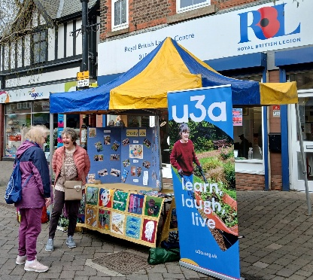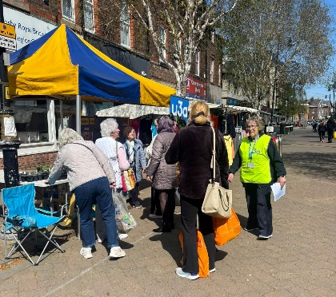  THEATRE TRIP:  The Little Theatre, Southport  Thursday 18th June at 7:30 pm. Tickets: £15  “GOD OF CARNAGE” – staged by Southport Dramatic Club as an ‘in the round’ production in the BAR area.  A polite discussion about a playground incident between children quickly descends into a savage battleground of accusations, insults, and long-buried resentments.  TRAIN: All Stations to Southport  Details: Lorna Rothwell – 07941 843 090  LUNCH CLUB – Next Date: Mon. 18th May at 12:15 pm.  LOCATION: West Lancs. Golf Club - Free Parking on site. The Golf Club is situated next to Hall Road Train Station.  Further Details from Joan Sheerin – 0151 928 5383  DAY TRIP – THIS MONTH  MEOLS HALL – visit this delightful 12th Century House in Churchtown, Southport.  Mon. 25th May – TICKETS: £5 on the Door.  TRAVEL: The 12:37 TRAIN from Blundellsands (or Station of your choice) to SOUTHPORT and then No. 49 BUS from Lord Street to MEOLS HALL.  (N.B. Meols Hall is opposite the Botanic Gardens.)  CONTACT: Lorna Rothwell on 07941 843 090  GROUP VACANCIES:  There is a VACANCY for ONE Member to join the PLAY-READING GROUP on the 3rd MON. of the month at 10:30 am. Also a VACANCY for ONE Member to join the READING GROUP 2 on the 4th MON. of the month at 11:00 am.  ENQUIRIES for BOTH Groups: Lorna on 07941 843 090  UNDER THE SPOTLIGHT….  BOARD GAMES GROUP – led by ANNE HANDLEY  Board Games is a new group. We have held three meetings so far, in an excellent room in Crosby Library, with enough tables to play several games at once. Every meeting is different. The first one began with just one table of six playing Rummikub. Newcomers or experienced, we all learnt together and it was quite evenly matched. People bring along games that they think will go down well - games that are easy-to-learn, fun and interesting. We’ve enjoyed Quirkle, Triominoes, Code Names and Battle Sheep. With 12 members we could easily fit in a few more.  If you want to come along - 2pm on the 4th Monday of the month - just let Anne know on 07732 948590  